**Capstone Project - The Battle of Neighborhoods**

**Capraru Ovidiu**

**1.Introduction**

One of the problems for starting a business today is the large concentrations of businesses in an area resulting in a competition that can bring business failure. The purpose of this research will be to determine the optimal business to open in a location based on local competition.

**2.Data**

I will be using shop locations and categories from New York and Toronto. All data is provided by Foursquare. The data will be cleaned and plotted on a map to show distribution and grouped to find the highest and lowest competitive business.

**3. Methodology**

The method proposed is based on mapping the data to observe the density of businesses to decide on the best possible position in conjecture with zone population density. Along with this is the establishing of the business type density which is done by counting the specific types of businesses in each selected region.

The tools used were seaborn for plotting data, geopy was used to transform an address in latitude and longitude (used to find the geographical positions of the cities) and folium as the data provider.

**4.Results and Discussions**

**New York Business Distribution** 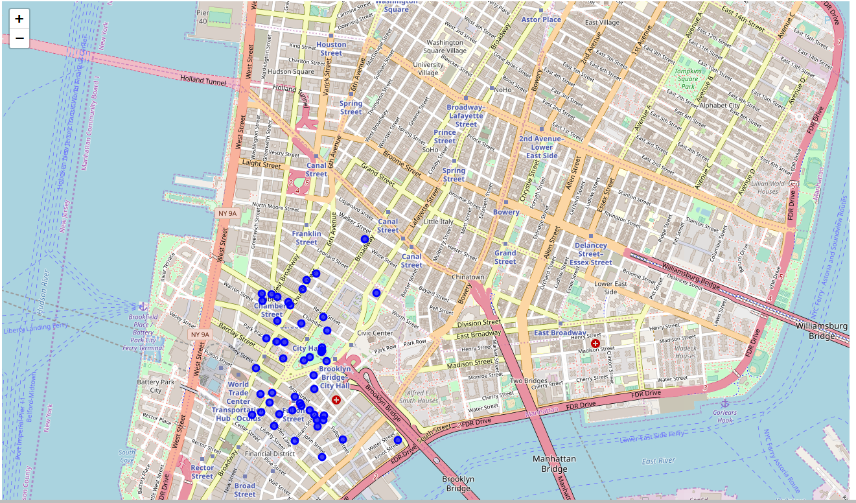

**Toronto Business Distribution**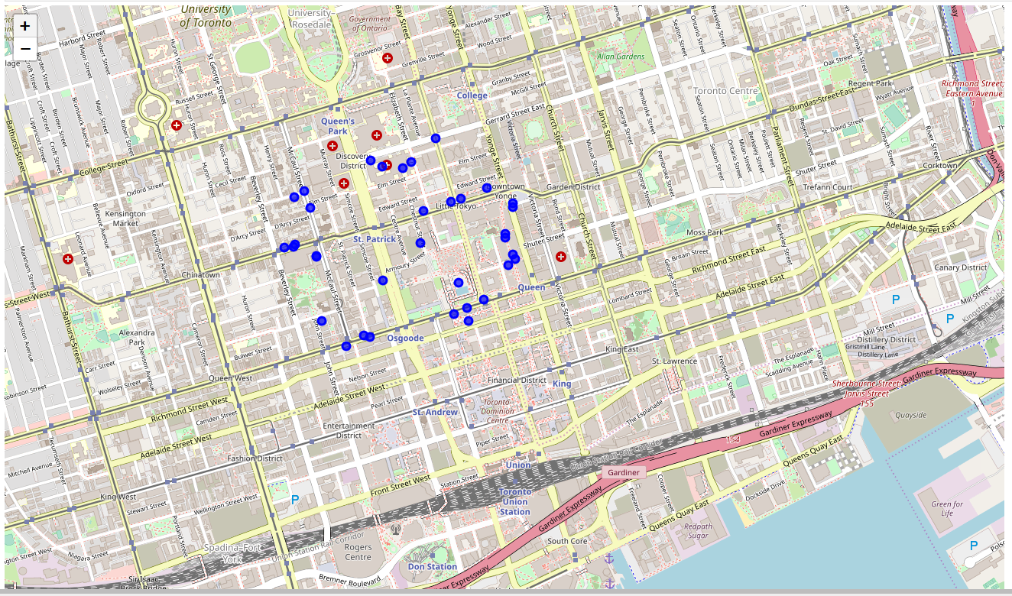

From the first two pictures we can observe the business distribution in the two cities with the New York one having them condensed in clusters while in Toronto they are spread out evenly.

**Business Type Concentration Distribution in New York and Toronto**

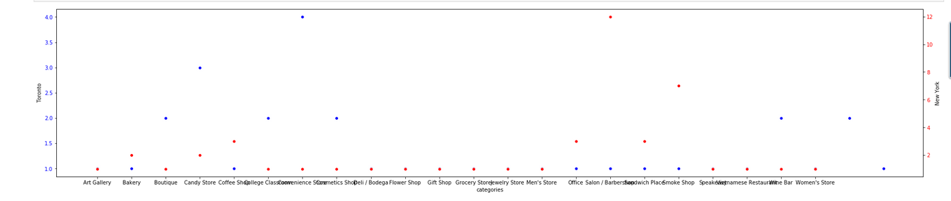

And lastly the business type distribution image as shown above show which business have the highest competition rating in the specified zones along with a comparison between the predominant type of business in each location.

**5.Conclusion**

In conclusion we can now deduce with a certain amount of precision which business to open such as there is minimum competition along with an approximate position for it. Additional research can be made to discover the amount of profit that can be made by opening a business in a highly competitive area or even a correlation between location-profit-competition.